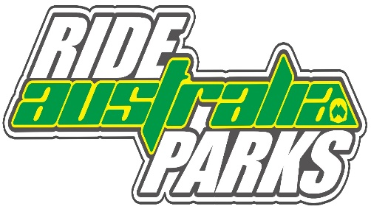

Ride Park Australia – Ride Day Application

Club or Promoter: |  |  |  |  | Contact Name:
Postal Address: |  |  |  |  | Contact Number:
Email:
Meeting Name: |  |  |  |  | Venue Name:
Track Licence No’s: |  |  |  |  | Fee: $ |  |  | 25.00
 |  |  |  |  | Date/s:
Ride Park Manager (Must have First Aid Certificate)
• Official/s listed above must be present for the entire day. Motorcycling NSW must be immediately notified in writing of any changes.
Motocross  Supercross  Stadium Motocross  Grass Track Motocross  Classic Motocross |  | Dirt Track  Short Track  Long Track  Speedway  Grass Track Dirt Track  Classic Dirt Track | Enduro  Cross Country  Pony Express  Sprint |  |  | Minikhana  Minicross – MK  Mini Enduro – MK  Mini Trials - MK |  |  | Road Race  Historic Road Race  Moto-Trials  Super track  Supermoto
Mini (4-U7)  _{Attach Nipper Deed}  Junior(7-U16)  _{Nominate Age _______________}  Senior (16+) |  | Senior Quads (16+)  Junior Quads (ACT Only)
The decision to cover such events is at the discretion of the Management of Motorcycling NSW Limited. It is at the Promoter’s discretion and highly recommended that insurance cover is in place for activities not covered by MA insurance policy.
I wish to apply for approval to conduct the above-described meeting and hereby agree to abide by the Ride Parks Australia Guidelines ‘Interim Covid-19’ Motorcycling NSW Limited. This application is made with the approval of the landowner and/or any authority controlling the use of the course or track. I understand and hereby accept that the promoter is responsible for paying the excess on any public liability insurance claims arising out of this meeting.
APPLICANTS NAME |  |  | SIGNATURE |  |  |  |  |  |  | DATE
Checklist
All applications, FULLY COMPLETED MUST be received in the Motorcycling NSW Office no later than ONE WEEK prior to the event
Credit Card |  | VISA | MASTERCARD | Expiry Date |  | / |  | Security Code  3 digits on back of card
/ / /
Account Name |  |  |  |  | Signature

